1. What is the emissions per capita of Canada? Since the user needs a specific emissions statistic, simply click on Canada in Worldwide Emissions map for the answer: Use the other two visualizations to acquire insight relating to long term changes and overall trends.

**17.72**

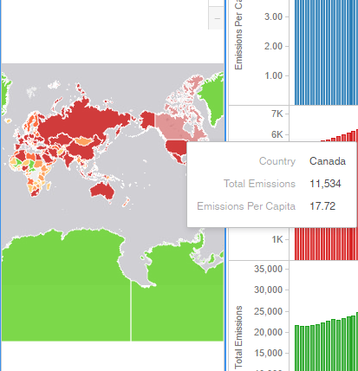

2. What is the overall trend in worldwide emissions?

**From the below visualization, we can see the emissions from coal, natural gas and petroleum kept rising from the year 1990 and 2010.**

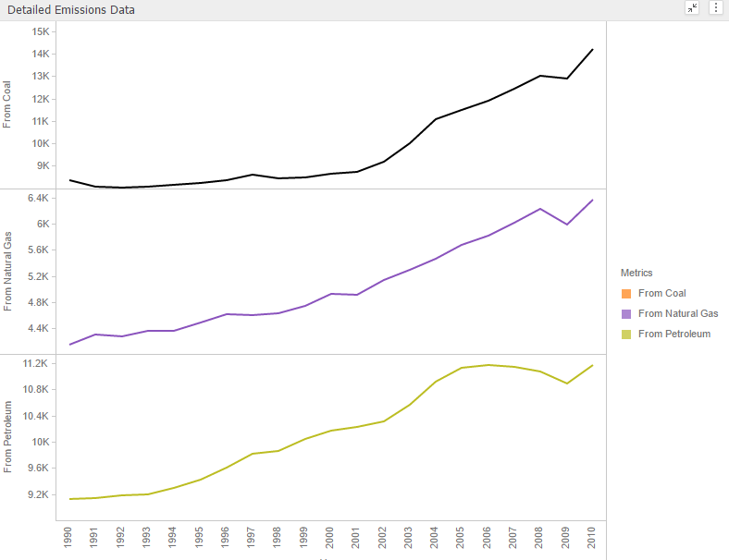

3. Notice that overall emissions declined in 2009, the only year in the total number of years surveyed that indicates emissions decreases in all three emissions sources. Why is that? What broader socio-political context might explain this single yearly decrease?

**Total emissions reduced despite increase in population due to which the emissions per capita also increased. This is all because of global recession.**

